A Comparative Review of GANs and Diffusion Models in Medical Imaging

Greeshma Kalsham¹ · Manidweep Sharma¹ · Dameesh Kumar¹

Abstract

Medical imaging is a vital component of modern healthcare, enabling non-invasive visualization of internal body structures for diagnosis, treatment planning, and disease monitoring. Despite significant advancements, challenges such as limited access to large, diverse datasets, privacy concerns, and the rarity of certain medical conditions hinder the development of robust AI models. Generative Adversarial Networks (GANs) and Diffusion Models offer transformative potential in addressing these challenges by generating synthetic medical images. GANs, introduced in 2014, are known for their ability to produce images rapidly and enhance unsupervised learning, though they often face challenges with training stability and mode collapse. Diffusion models, on the other hand, overcome many of these limitations by generating high-quality and stable images, albeit at the cost of greater computational resources and longer training times. This review provides an in-depth analysis of GANs and Diffusion Models within the context of medical imaging, with a strong focus on their use in generating synthetic medical images. We evaluate specific implementations, including StyleGAN, Pix2Pix, DDPM, and MedSegDiff-V2, analysing their performance in applications such as X-rays, MRIs, and CT scans. Our findings suggest that while both technologies have distinct strengths and weaknesses, their use should be tailored to specific case requirements. Future research is encouraged to refine these models further and explore hybrid approaches to address current limitations and maximize their potential in advancing medical imaging.

Keywords

GANs, Diffusion Models, Medical imaging, Deep Learning, Image synthesis.

1. Introduction
Medical imaging plays a crucial role in modern healthcare. Its enabling non-invasive visualization of internal body structures for diagnosis, treatment planning and monitoring of various health conditions. This field encompasses a wide range of modalities including X-rays, computer tomography (CT), magnetic resonance imaging (MRI) and ultrasound. It is not only revolutionizing disease diagnosis but has also transformed how medical professionals diagnose diseases [11].

Deep learning, especially convolution neural networks, has been used as a leading machine learning tool. In comparison to traditional machine learning approaches, it is observed that deep learning improves accuracy. While there are standard tests like MRI and CT scans, AI imaging provides faster results in some cases and helps in guiding the treatment [7]. Despite the advancements in medical imaging there are several challenges that necessitate the generation of synthetic medical images. The most important thing is access to large and diverse medical datasets due to privacy concerns and limited resources. Secondly, some medical conditions are rare, making it difficult to obtain sufficient real-world examples for training AI models. Lastly, synthetic images can be used to augment existing datasets improving the performance of deep learning models. In the era of modern innovation, Generative Adversarial Networks (GANs) and Diffusion models are two image creation techniques. Global health systems and specifically medical imaging practices have been profoundly changed by the COVID-19 epidemic. From [3], the research underscores the growing importance of synthetic data in medical learning applications, including medical imaging. The benefits of synthetic data generation not only include augmenting limited datasets especially in rapidly evolving situations but also eliminates the use of real patient data to overcome privacy concerns in medical research and improves the generalizability of AI models across different populations [31]. To address the scarcity of medical imaging data particularly for novel diseases this paper talks about two leading approaches for generating synthetic medical images.

Generative Adversarial Network which was introduced by Goodfellow et al. in 2014 has revolutionized the field of generative modelling [40]. GANs have an adversarial training process which includes two neural networks- a generator and a discriminator. The aim of the generator is to produce synthetic data which resembles real data, while the discriminator distinguishes between the real and the images/samples generated. In recent years, diffusion models have gained high popularity due to their ability to overcome the limitations of GANs especially with training stability and the quality of images generated. Unlike GANs, diffusion models work by gradually adding noise to the data and reverses the process through learning. It gradually adds Gaussian noise and denoises it to generate the data samples [17]

GANs has been widely used in various domains and is a popular type of generative model. From all the previous research diffusion models have shown better performance in generating high quality synthetic images [25]. This review paper focuses on comparing GANs and diffusion models, examining the advantages, disadvantages, and various models used in previous research. By analyzing existing studies, we aim to provide a comprehensive evaluation of these generative techniques and their applications, highlighting which approaches are more effective for generating realistic synthetic images to support advancements in AI-driven healthcare tools. By comparing these two approaches, researchers can identify their respective strengths and weaknesses such as mode collapse and training stability in GANs which will potentially lead to hybrid or new architectures [3].

The paper also discusses the use of GANs and diffusion models in medical segmentation for critical areas such as chest X-rays, brain scans, and cardiac imaging. By examining their performance in these domains, we explore how these models address challenges in medical data generation and analysis. Additionally, we review specific GAN and diffusion models applied in healthcare, the datasets utilized, and key qualitative metrics used to evaluate their performance. This comparison identifies strengths and weaknesses, such as mode collapse in GANs and computational costs in diffusion models, which could inspire hybrid or novel architecture.

2. Literature Review

GANs
Generative Adversarial Networks (GANs) consist of two dominant neural networks called generators and discriminators that compete against each other to improve each other’s performance by which it can generate synthetic and realistic images [6]. Several notable GAN variants have advanced the field of image synthesis. Cycle GAN introduced unpaired image-to-image translation using cycle consistency losses, enabling tasks like style transfer without the need for paired training data [29]. StyleGAN revolutionized high-quality image generation, particularly for faces, by introducing a latent style space that allows fine-grained control over image attributes [29]. These models have significantly improved the quality, diversity, and controllability of generated images. However, GANs still face challenges such as training instability, potential for uncontrolled learning in unsupervised settings, and the need for careful tuning of network structures and parameters. While GANs show promise in medical imaging applications, generating high-quality, clinically relevant synthetic medical data remains more challenging than generating natural images due to the complexity of anatomical structures, the importance of subtle diagnostic features, and the need for clinical validity [34].

Diffusion Models
Diffusion models are built on the idea of non-equilibrium statistical physics [32], which slows destroys the structure if the data iteratively and parallelly learns the reverse process. When the reverse process is performed, the data or the image gets restored. The approach presented by [32] which is the basis of the diffusion models, will provide great flexibility and tractability.

The core concept of diffusion models is based on a two-phase process: the forward process and the reverse process. Initially, the model is trained on datasets of clean images, systematically transforming them into noise. This transformation involves increasing the amount of noise over multiple steps until the images become indistinguishable from random noise, a phase referred to as the forward process [6]. The noise that gets added to the images every step of training is the Gaussian noise [8].

Once the model has been trained, it learns to reverse this noise transformation, utilizing the knowledge gained during training. In this reverse process, the model begins with random noise and progressively denoises it, generating coherent images. With each iteration, diffusion models effectively reconstruct high-quality images from pure noise, demonstrating their capability as powerful generative tools [6]. The reverse process is defined as a Markov chain with Gaussian transitions [8].

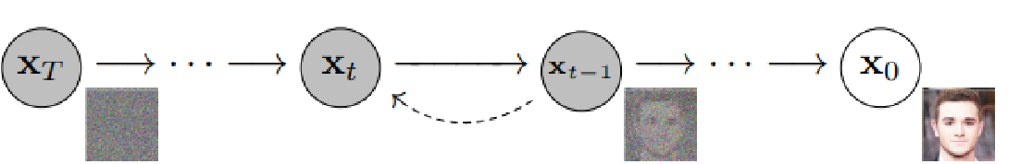

Figure 1: Adapted from[8], Graphical model representation of Reverse Process.

Methodologies Used in Literature
With today’s current technology, multiple advancements have been made in Generative Adversarial Networks (GANs) and Diffusion models. When we start to compare GANs and diffusion models, there are a couple of common metrics that are used to compare, such as Fréchet Inception Distance (FID) and Inception Score (IS). FID measures the distance between feature vectors on generated and real images. It then asses the diversity and quality diversity using a pre-trained inception network [11]. The inception score uses the quality of the generated images to make an evaluation based on a pre-trained inception model. It looks at how well the images are displayed in distinct classes and the diversity within those classes [29].

There are multiple similarities when it comes to both models. Both models require massive datasets to be trained properly. This can be especially hard to do when it comes to the medical field, as very little information can be available due to multiple laws [34]. Along with this, both models require a large amount of computing power to effectively train the models.

Although both models can be used to generate a variety of images in different fields, they do have their limitations and differ in some ways. GANs are sometimes unstable and suffer from mode collapse during training while diffusion models have better stability and control. [29]

GANs, once properly trained, are known for generating images faster, however, diffusion models tend to produce higher-quality images but also take more resources [17]

3. Methodology Used
This paper will review the capability and performance of GAN and Diffusion models in the generation of synthetic images for different medical applications. Along the way, it will compare the two techniques to come up with a model that produces more realistic and clinically useful images, hence helping in augmenting medical images, generating data, and training models on disease diagnosis. Research can leverage a number of publicly available medical imaging datasets across various domains, including radiology, dermatology, and pathology. Examples include X-rays, MRI, CT scans, and histopathology slides representing each type of image modality, all labeled with specific conditions or markers of diseases.

A systematic review of the literature was performed for the application of GAN and Diffusion models for generating synthetic medical images.
- The search keywords were focused on "GAN medical imaging" and "Diffusion models for diagnosis."
- Database Search: Searched academic platforms such as PubMed, IEEE Xplore, arXiv, after filtering for recent peer-reviewed papers.
- Screening: Titles and abstracts reviewed for relevance; theoretical-only studies excluded.
- Metrics-Based Selection: Chose papers based on impact-citation, clinical relevance, reproducibility-shared datasets/code, and performance metrics such as SSIM and FID.
- Diversity: Included studies involving different imaging modalities such as MRI, CT, and histopathology.
The final goal will be to understand various method in medical imaging tasks, therefore supporting the advancement of medical data augmentation and the more effective training of predictive health models.

3.1 Datasets
These are some of the mostly used medical imaging datasets across a few disciplines, and for each, there is a publication explaining its creation and uses:
- NIH Chest X-ray Dataset.[36]
- CheXpert Dataset.[12]
- LUNA16 (Lung Nodule Analysis 2016).[2]
- HAM10000 (Human Against Machine with 10000 Training Images).[33]
- COVID-19 Radiography Database.[4]
GANs and Diffusion models are useful for synthesizing realistic images in medical imaging datasets to enhance diversity and balance across categories. Synthetic images allow for better training of diagnostic models, improving performance in tasks like identifying conditions that are under-represented and supporting the detection of diseases. The generated images will increase the dataset size for those classes that have limited data, enabling more accurate and robust training of models applied in various medical applications where real data is not readily available or balanced.

4. Models Used
The following are the types of GANs that have been used in the past for the medical image generation, the following explains each GAN briefly:

CGAN (Conditional Generative Adversarial Network)

Conditional Generative Adversarial Networks were an extension from the original GAN framework. It allows data generation to be conditioned on specific attributes or labels. The key novelty with CGAN is to provide extra input information, y, to both generator and discriminator that conditions the process of generation. Note that in a CGAN, the inputs to the generator G are random noise z and the conditional information y; both generate fake samples, G(z|y). Discriminator D takes the real or generated samples and conditional information and tries to tell apart real from generated, considering the conditioning, so the model will have the capability to generate samples with desired characteristics, for example, MNIST digits of specific classes or images containing certain tags. [22]

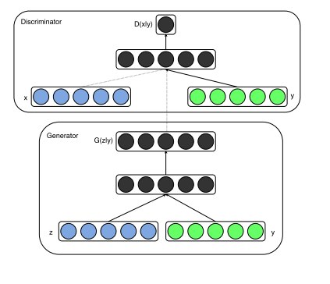
Conditional Generative Adversarial Networks (Adapted from [22])
Style GAN

StyleGAN is a new approach to GAN architecture, substantially improving the quality and controllability of images generated with it. The core novelty resides in an adaptive instance normalization technique, which lets the network disentangle high-level attributes-formerly styles-of generated images from stochastic variation. The StyleGAN generator consists of two sub-networks: a mapping network that transforms the input latent code to an intermediate latent space, while a synthesis network generates the image based on styles from this intermediate space. This enables fine-grained control over image synthesis, including style mixing at varying resolutions, which leads to better disentanglement of image features. This model provides an outstanding result in the generation of high-resolution images, including faces, with unprecedented quality and variation. Their work contributes to image quality but also introduces novelty regarding the factors of variation in GAN-generated images and paves ways toward more controllable and interpretable generative models.[15]

Pix2Pix (Image-to-Image Translation)

Pix2Pix, proposes a generic approach for image-to-image translation tasks using conditional Generative Adversarial Networks. Network can be applied to a multitude of different image processing problems with no task-specific adjustment. The model Pix2Pix has a generator which learns the mapping of the input image to the output image and a discriminator learning to differentiate between real and generated image pairs. The necessary steps would be to adapt a generator as the U-Net architecture, which incorporates skip connections in order to preserve low-level information and use Patch GAN as the discriminator that operates on image patches rather than operating on the whole image. It is trained jointly with adversarial loss and L1 loss to have realistic and accurate output. It shows the robustness of Pix2Pix on various applications, such as labels-to-photorealistic images, reconstruction of objects from edge maps, colorization, and its potential to be a general-purpose solution for image-to-image translation problems.[13]

The following are the types of Diffusion Models that have been used in the past for the medical image generation, the following explains each Diffusion Model briefly:

Denoising Diffusion Probabilistic Model (DDPM)

Denoising Diffusion Probabilistic Models introduce another new direction toward generative modelling. DDPMs rely on a Markov chain that progressively adds Gaussian noise to the data and then learns to reverse this process in order to generate samples. The model defines a forward diffusion process that gradually adds noise to the data, and a reverse process which is learned to generate data via the reversal of this diffusion. The model is trained on a variational bound to the data likelihood. A key insight is rewriting the loss function in a way that enables efficient training by optimizing for random terms using stochastic gradient descent. DDPMs generate high-quality samples competitive with the state-of-the-art GANs.[9]

MedSegDiff-V2

MedSegDiff-V2 is a new approach to medical image segmentation by implementing a transformer mechanism together with a diffusion-based model. The architecture consists of two significant parts: a Diffusion Model and a Condition Model, both based on UNet. It develops two new kinds of conditioning mechanisms: the Anchor Condition with Uncertain Spatial Attention (U-SA) and Semantic Condition with Spectrum-Space Transformer (SS-Former). While the anchor condition helps to reduce the variance of diffusion, the semantic condition models the interaction between the segmentation noise and semantic features. During training, a combination of noise prediction loss and anchor loss is used together with soft dice loss and cross-entropy loss in MedSegDiff-V2. The superior performance shows up in 20 different medical image segmentation tasks across a wide range of imaging modalities. MedSegDiff-V2, by adapting the main insights of diffusion models and transformer mechanisms, effectively indicates a big step in medical image segmentation. [13]

Latent Diffusion Models

Latent diffusion models are a new paradigm in image synthesis; the process of diffusion models acts in the latent space created by a pre-trained autoencoder. These are designed to work in two steps: first, images are compressed by an autoencoder into a lower-dimensional latent space; then, train a diffusion model in this latent space. The biggest positives of LDMs are : they show significantly improved quality at image generation for the same computational cost when compared to pixel-space diffusion models. This is because of much weaker computational requirements both at training and at inference time. Since the LDM operates in this compressed latent space, it can achieve a very good trade-off between complexity reduction and preservation of detail. The authors, for the first time, integrated cross-attention layers into the model architecture, allowing for flexible conditioning in tasks such as text-to-image synthesis or layout-to-image generation. Current large diffusion models show state-of-the-art results on a wide variety of applications, ranging from image in-painting and class-conditional image synthesis over high-resolution image generation.[30]

5. Medical Segmentation
5.1 Chest X Rays

GANs have been employed to generate synthetic chest X rays’ images for training various classification systems. X rays serve as a first screening test for any lung infectious diseases. From [27] , the performance of the model which classifies Covid-19 was improved by using DCGAN and adding the generated synthetic COVID-19 and pneumonia chest X-ray images, which were combined with the original dataset to augment the training data for the classification model. This approach aimed to address the limited availability of COVID-19 chest X-ray data, enhance the diversity of the training dataset. After using the images generated by GANs the accuracy was increased by 3% and precision by almost 6%. From [39] , the study demonstrated that GAN-based augmentation is particularly effective when training data is limited, which is often the case in medical imaging. The CheXpert dataset which consisted of 3 classes was expanded using GAN augmentation which helped address severe class imbalances. The model’s performance was measured using ROC-AUC score and it was found that GAN augmentation outperformed both standard and no augmentation. Figure 2 shows the different classes of images generated by GAN in comparison to real images. In [23] , the researcher employed a novel architecture called Inception-Augmentation GAN (IAGAN) to generate synthetic chest X-ray images. After training IAGAN, the generator was able to create three new images for each input image which significantly expanded the dataset. Another important feature of IAGAN is its ability to generate domain specific data regardless of the class of input images, allowing for unsupervised data augmentation when labels are not available for all images. It also outperformed traditional augmentation methods with an accuracy of 80% and sensitivity of 82%.

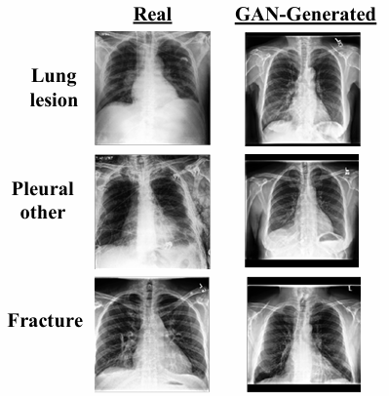
Figure 2. Adapted from

The paper [35], highlights that diffusion models outperform GANs in terms of image quality and realism in all the datasets used. This performance is often demonstrated using metrics like Fréchet Inception Distance and Inception Score where diffusion models have shown to produce more lifelike images. Figure 3 shows a comparison of real and synthetic images using GANs and diffusion models. Similarly, diffuX2CT diffusion model is designed to address the limitations like artifacts and low details in 3D structure when using GANs. GAN based models struggle with recovering fine details which results in blurry images. In contrast, the diffusion model enhances structural quality [37]. Medfusion which is based on latent diffusion captures a wider range of structural variations in chest X-rays allowing for more accurate synthetic image generation. This model has shown higher fidelity and recall rates suggesting diffusion models advantages on diverse medical images datasets [26].

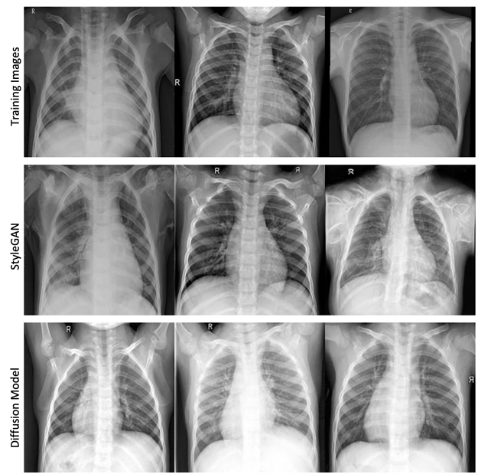
Figure 3, adapted from
  - Brain Images
Generative adversarial networks (GANs) and diffusion models are the two most important classes of models in medical imaging, more specifically, brain scans. These approaches have different advantages and challenges when applied to this domain. GANs have been commonly used for the generation of synthetic brain MRI images to augment datasets for training machine learning models. This will be especially useful in situations where real medical data is difficult to get in large quantities due to privacy and other ethical issues. These work by generating realistic synthetic images and, hence, can be used for enriching the diversity of training datasets; this enhances the performance. Diffusion models have shown to make high-quality, anatomically valid, and slice-consistent synthetic brain images.

According to [24] focused on an investigation of a novel approach to the generation of synthetic MRI images of brain tumors to overcome problems such as a lack of medical datasets and class imbalance. The work proposes the AGGrGAN model, which combines two DCGAN variant models and Wasserstein GAN. This combination will capture both localized and distributed features of images, improving the quality of the generated data. And style transfer techniques are also conducted to enhance the similarity between actual and the generated images by the models used.
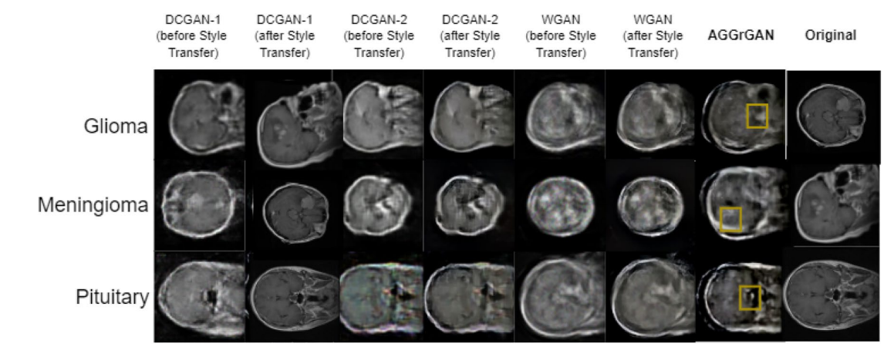
Figure 4, adapted from [24]
According to [28] accentuates the transformative role of AI in medical imaging, especially GAN. It shows how AI-generated synthesized brain images help solve critical issues related to a shortage of annotated medical data and imbalance in tumor versus non-tumor cases. These models, relying on innovations in style transfer and hybrid GAN architectures, generate realistic MRI scans that closely resemble clinical images; hence, they are highly useful in model training and validation. And [1]has comprehensively discussed the applications of GANs in brain MRI imaging. This has emphasized how GANs have revolutionized medical imaging, enabling synthetic data generation, image enhancement, segmentation, and domain adaptation. These models address the critical challenges of limited dataset availability, ensuring robust AI model training and improved diagnostic precision.

So, recent works have indicated huge potentials of GANs and diffusion models for applications in brain imaging, including realistic synthetic-image synthesis.

5.3
Image-generating models such as Generative Adversarial Networks (GANS) and Diffusion models have gained a lot of traction in the medical imaging industry for producing synthetic images of anatomical structures such as the heart. GANs have especially been utilized in generating realistic cardio MRI images which help expand the training data set for machine learning models. For example, GANs have shown promise and improvement in segmentation and classification tasks by creating synthetic images of real cardiac autonomy[38] [21]. Diffusion models which are a newer version of generating synthetic images help refine noisy data to help generate higher quality anatomically correct images of the cardiac system. When using both of these models they have demonstrated potential for generating detailed cardiac structures and help detect anomalies in medical imaging [8] [20]. Both methods help overcome challenges in cardiac research where obtaining high-resolution data sets is usually limited by ethical considerations, financial constraints, and medical laws. By generating synthetic heart images GANs and diffusion models drive advancements in diagnostic development, support various situations and cardiac conditions, and contribute to the progress of personalized medical applications.

6. Applications & Challenges
From [29], advanced types like StyleGAN and BigGAN excelled at creating realistic and diverse images. StyleGAN can also control various aspects of generated images via latent spaces which increases quality of the images. They don’t always require labeled data and works well in unsupervised manner especially
in CycleGAN [17]GANs not only improve cross-modality (translating MRI to CT images) synthesis but also reduces the risks and cost associated and supports enhanced diagnostic decision [16] . In medical imaging where data availability is a challenge, GANs was used especially in applications like brain tumor segmentation [34]. In diffusion models, the training is stable and captures a broader distribution of data which makes it adept in handling complex datasets [29]. From [34], diffusion models generate synthetic data that achieved higher dice scores compared to GANs. It also tends to avoid overfitting on small datasets. They also maintain all the details and smoothness [17]. GANs are also known for their unstable training which leads to a model that produces limited diversity by focusing only on few patterns. When trained on large data, it fails to generalize well. Additionally, it is computationally expensive to achieve high quality images [34]. As the setup of GANs is too sensitive it requires well-tuned regularization and hyperparameters. Even though GANs generate high resolution images they do not always perform consistently across quality metrics, especially for medical image segmentation which is why clinicians are often hesitant to rely lacking on direct correlation to recognized medical scales such as Hounsfield units in CT [16] . Compared to GANs training, diffusion models is slower and the implementation is complex. The high computational demands can be a limiting factor in medical applications [17]

One of the challenges from GANs is the outputs generated are opaque. It becomes challenging to interpret the decision-making process since GANs are trained using a minmax function between generators and discriminators networks. This can lead to misdiagnoses or incorrect treatment if the clinical experts over-reply on AI outputs [19]. From [[10], suggests interpreting GAN outputs by visualizing which features are maximized in the generated data using activation maximization and other optimization techniques [18]. However, this has become critical especially in medical domains where achieving high accuracy is critical. GANs and many generative models are often considered as black boxes, and it becomes problematic especially in healthcare where the decisions have been understandable and justifiable [19]. Besides the applications of GANs and large language models the ethical considerations and bias must be carefully addressed. Though GANs and diffusion model has the ability to generate realistic images, one of the main concerns is if the training data is biased it can lead to false results and would also discriminate the generated images [19]. The second critical is the privacy of using AI technologies to generated realistic images without their consent. The questions of who takes the responsibility of the data created by AI is still unanswerable.

6.1 Qualitative Metrics

While FID and Inception score are widely used quantitative metrics to assess the quality of GAN generated images, they might fall short in terms of medical applications. These metrics rely on pre-trained models and often overlook the domain specific nuances. Small anatomical details might go unnoticed by these metrics [5]. Therefore, integrating human evaluation especially with experienced radiologists is essential for assessment of these medical images. In [14] , Image Turing Test was used where 6 radiologists with different experiences to differentiate real from synthetic images. The radiologists achieved moderate accuracy in identifying synthetic images with overall accuracy rates of around 67.42% and 69.92% in two trials. In [26] , qualitative testes involved comparing images generated by Medfusion and GANs with real images across 3 datasets. The authors conducted the tests by displaying 50 synthetic images with 50 real images allowing a side-by-side visual comparison by two reviewers. The reviewers notes that Medfusion’s images were found to closely resemble like real images. Thus, this qualitative evaluation provides insights into model limitations and areas that needs improvement for practical medical applications.

7. Future Direction
The future work should focus on refining the architecture of GANs which will mitigate mode collapse. To make diffusion models more viable and reduce the computational demands, researchers should explore accelerated and denoising sampling techniques. The developers should adopt eliminating bias in the dataset right from data collection step by ensuring gathering data from diverse resources and from various demographics. Techniques and adversarial training such as data augmentation and balancing the dataset will help in reducing the bias generated in the training dataset [18]. Besides the traditional metrics used in capturing biases, the developers should employ metrics which will support the fairness in the outputs generated. From [[10], applications like generating medical images where concepts like GANs and deep neural networks are often used, AM-FM decomposition techniques are suggested for outputs to be more interpretable. This process includes breaking down the images into the frequency components which is useful to trace how the features contribute to a prediction. Human Computer Interaction (HCI) approach is highly emphasized which combines the human expertise with AI which allows domain experts like medical doctors to validate the outcomes of machine learning.

7. Conclusion
In conclusion, this paper proves a detailed comparison between Generative Adversarial Networks (GANs) and Diffusion Models in the context of medical image generation. Through extensive analysis we have identified distinct advantages and limitations of both approaches. GAN’s demonstrates great capabilities in fast image generation and cross-modality synthesis which can be used as valuable tools in medical imaging where speed is key. However, they lack training stability and mode collapse which can be an issue as accuracy and reliability are extremely important. Diffusion models require greater computational resources and longer training times; however, they have significantly greater performance when it comes to image quality, training and complex data distributions. They strive in maintaining detailed features and are good at avoiding overfitting on small datasets.

When choosing which technology should be used, it should be done on a case-by-case basis. Limitations to keep in mind when choosing should be time, requirements, available resources, generation speed and quality of output. As both GAN’s and Diffusion evolve, future developments should focus on each one’s limitations while maintaining their strengths. The integration of these models with human expertise, improved interpretability mechanisms, and robust bias mitigation strategies will be crucial for their use in clinical settings.

References

[1] Hazrat Ali, Rafiul Biswas, Farida Ali, Uzair Shah, Asma Alamgir, Osama Mousa, and Zubair Shah. 2022. The role of generative adversarial networks in brain MRI: a scoping review. Insights into Imaging 13. https://doi.org/10.1186/s13244-022-01237-0
[2] Alberto Traverso 1 g h a, Thomas de Bel o, Moira S.N. Berens n, Cas van den Bogaard o, Piergiorgio Cerello h, Hao Chen m, Qi Dou m, Maria Evelina Fantacci k i, Bram Geurts b, Robbert van der Gugten n, Pheng Ann Heng m, Bart Jansen e f Arnaud Arindra Adiyoso Setio 1 a. 2016. Validation, comparison, and combination of algorithms for automatic detection of pulmonary nodules in computed tomography images: The LUNA16 challenge. (2016).
[3] Richard J. Chen, Ming Y. Lu, Tiffany Y. Chen, Drew F. K. Williamson, and Faisal Mahmood. 2021. Synthetic data in machine learning for medicine and healthcare. Nat Biomed Eng 5, 6 (June 2021), 493–497. https://doi.org/10.1038/s41551-021-00751-8
[4] Joseph Paul Cohen, Paul Morrison, Lan Dao, Karsten Roth, Tim Q Duong, and Marzyeh Ghassemi. 2020. COVID-19 Image Data Collection: Prospective Predictions Are the Future. (June 2020). https://doi.org/10.59275/j.melba.2020-48g7
[5] Ricardo de Deijn, Aishwarya Batra, Brandon Koch, Naseef Mansoor, and Hema Makkena. 2024. Reviewing Fid and Sid Metrics on Generative Adversarial Networks. January 27, 2024. Academy and Industry Research Collaboration Center (AIRCC), 111–124. https://doi.org/10.5121/csit.2024.140208
[6] P Dhariwal and A Nichol. 2021. Diffusion Models Beat GANs on Image Synthesis. Advances in Neural Information Processing Systems. (2021), 34.
[7] Hayit Greenspan, Bram Van Ginneken, and Ronald M. Summers. 2016. Guest Editorial Deep Learning in Medical Imaging: Overview and Future Promise of an Exciting New Technique. IEEE Transactions on Medical Imaging 35, 1153–1159. https://doi.org/10.1109/TMI.2016.2553401
[8] Jonathan Ho, Ajay Jain, and Pieter Abbeel. 2020. Denoising Diffusion Probabilistic Models. (June 2020). Retrieved from http://arxiv.org/abs/2006.11239
[9] Jonathan Ho, Ajay Jain, and Pieter Abbeel. 2020. Denoising Diffusion Probabilistic Models. (June 2020). Retrieved from http://arxiv.org/abs/2006.11239
[10] Andreas Holzinger, Chris Biemann, Constantinos S. Pattichis, and Douglas B. Kell. 2017. What do we need to build explainable AI systems for the medical domain? (December 2017). Retrieved from http://arxiv.org/abs/1712.09923
[11] Shah Hussain, Iqra Mubeen, Niamat Ullah, Syed Shahab Ud Din Shah, Bakhtawar Abduljalil Khan, Muhammad Zahoor, Riaz Ullah, Farhat Ali Khan, and Mujeeb A. Sultan. 2022. Modern Diagnostic Imaging Technique Applications and Risk Factors in the Medical Field: A Review. Biomed Res Int 2022, (June 2022), 1–19. https://doi.org/10.1155/2022/5164970
[12] Jeremy Irvin, Pranav Rajpurkar, Michael Ko, Yifan Yu, Silviana Ciurea-Ilcus, Chris Chute, Henrik Marklund, Behzad Haghgoo, Robyn Ball, Katie Shpanskaya, Jayne Seekins, David A. Mong, Safwan S. Halabi, Jesse K. Sandberg, Ricky Jones, David B. Larson, Curtis P. Langlotz, Bhavik N. Patel, Matthew P. Lungren, and Andrew Y. Ng. 2019. CheXpert: A Large Chest Radiograph Dataset with Uncertainty Labels and Expert Comparison. (January 2019). Retrieved from http://arxiv.org/abs/1901.07031
[13] Phillip Isola, Jun-Yan Zhu, Tinghui Zhou, and Alexei A. Efros. 2016. Image-to-Image Translation with Conditional Adversarial Networks. (November 2016). Retrieved from http://arxiv.org/abs/1611.07004
[14] Miso Jang, Hyun jin Bae, Minjee Kim, Seo Young Park, A. yeon Son, Se Jin Choi, Jooae Choe, Hye Young Choi, Hye Jeon Hwang, Han Na Noh, Joon Beom Seo, Sang Min Lee, and Namkug Kim. 2023. Image Turing test and its applications on synthetic chest radiographs by using the progressive growing generative adversarial network. Sci Rep 13, 1 (December 2023). https://doi.org/10.1038/s41598-023-28175-1
[15] Tero Karras, Samuli Laine, and Timo Aila. 2018. A Style-Based Generator Architecture for Generative Adversarial Networks. (December 2018). Retrieved from http://arxiv.org/abs/1812.04948
[16] Salome Kazeminia, Christoph Baur, Arjan Kuijper, Bram van Ginneken, Nassir Navab, Shadi Albarqouni, and Anirban Mukhopadhyay. 2020. GANs for medical image analysis. Artificial Intelligence in Medicine 109. https://doi.org/10.1016/j.artmed.2020.101938
[17] Denis Kuznedelev, Valerii Startsev, Daniil Shlenskii, and Sergey Kastryulin. 2024. Does Diffusion Beat GAN in Image Super Resolution? (May 2024). Retrieved from http://arxiv.org/abs/2405.17261
[18] Archit Lasker. 2024. Exploring Ethical Considerations in Generative AI. Int J Adv Res (Indore) 12, 04 (April 2024), 531–535. https://doi.org/10.21474/ijar01/18578
[19] Annie Y.S. Lau and Pascal Staccini. 2019. Artificial Intelligence in Health: New Opportunities, Challenges, and Practical Implications. Yearbook of medical informatics 28, 174–178. https://doi.org/10.1055/s-0039-1677935
[20] Liang Li, Evangelos Mazomenos, James H. Chandler, Keith L. Obstein, Pietro Valdastri, Danail Stoyanov, and Francisco Vasconcelos. 2023. Robust endoscopic image mosaicking via fusion of multimodal estimation. Med Image Anal 84, (February 2023), 102709. https://doi.org/10.1016/J.MEDIA.2022.102709
[21] Yanxia Liu, Anni Chen, Hongyu Shi, Sijuan Huang, Wanjia Zheng, Zhiqiang Liu, Qin Zhang, and Xin Yang. 2021. CT synthesis from MRI using multi-cycle GAN for head-and-neck radiation therapy. Computerized Medical Imaging and Graphics 91, (July 2021), 101953. https://doi.org/10.1016/J.COMPMEDIMAG.2021.101953
[22] Mehdi Mirza and Simon Osindero. 2014. Conditional Generative Adversarial Nets. (November 2014). Retrieved from http://arxiv.org/abs/1411.1784
[23] Saman Motamed, Patrik Rogalla, and Farzad Khalvati. 2021. Data augmentation using Generative Adversarial Networks (GANs) for GAN-based detection of Pneumonia and COVID-19 in chest X-ray images. Inform Med Unlocked 27, (January 2021). https://doi.org/10.1016/j.imu.2021.100779
[24] Debadyuti Mukherkjee, Pritam Saha, Dmitry Kaplun, Aleksandr Sinitca, and Ram Sarkar. 2022. Brain tumor image generation using an aggregation of GAN models with style transfer. Sci Rep 12, 1 (December 2022). https://doi.org/10.1038/s41598-022-12646-y
[25] Gustav Müller-Franzes, Jan Moritz Niehues, Firas Khader, Soroosh Tayebi Arasteh, Christoph Haarburger, Christiane Kuhl, Tianci Wang, Tianyu Han, Sven Nebelung, Jakob Nikolas Kather, and Daniel Truhn. 2022. Diffusion Probabilistic Models beat GANs on Medical Images. (December 2022). https://doi.org/10.1038/s41598-023-39278-0
[26] Gustav Müller-Franzes, Jan Moritz Niehues, Firas Khader, Soroosh Tayebi Arasteh, Christoph Haarburger, Christiane Kuhl, Tianci Wang, Tianyu Han, Teresa Nolte, Sven Nebelung, Jakob Nikolas Kather, and Daniel Truhn. 2023. A multimodal comparison of latent denoising diffusion probabilistic models and generative adversarial networks for medical image synthesis. Sci Rep 13, 1 (December 2023). https://doi.org/10.1038/s41598-023-39278-0
[27] Sanjeeb Prasad Panday, Mani Prasad Dumre, Aman Shakya, and Basanta Joshi. 2024. Performance Enhancement of Covid-19 Chest X-Ray Image Classification Using GAN and CNN. In ACM International Conference Proceeding Series, March 12, 2024. Association for Computing Machinery, 12–20. https://doi.org/10.1145/3653946.3653949
[28] Ji Eun Park, Philipp Vollmuth, Namkug Kim, and Ho Sung Kim. 2022. Research Highlight: Use of Generative Images Created with Artificial Intelligence for Brain Tumor Imaging. Korean Journal of Radiology 23, 500–504. https://doi.org/10.3348/kjr.2022.0033
[29] Yingying Peng. 2024. A Comparative Analysis Between GAN and Diffusion Models in Image Generation.
[30] Robin Rombach, Andreas Blattmann, Dominik Lorenz, Patrick Esser, and Björn Ommer. 2021. High-Resolution Image Synthesis with Latent Diffusion Models. (December 2021). Retrieved from http://arxiv.org/abs/2112.10752
[31] Elena Sizikova, Andreu Badal, Jana G Delfino, Miguel Lago, Brandon Nelson, Niloufar Saharkhiz, Berkman Sahiner, Ghada Zamzmi, and Aldo Badano. 2024. Synthetic data in radiological imaging: current state and future outlook. BJR|Artificial Intelligence 1, 1 (March 2024). https://doi.org/10.1093/bjrai/ubae007
[32] Jascha Sohl-Dickstein, Eric A Weiss, Niru Maheswaranathan, Surya Ganguli, and Sganguli@stanford Edu. Deep Unsupervised Learning using Nonequilibrium Thermodynamics.
[33] Philipp Tschandl, Cliff Rosendahl, and Harald Kittler. 2018. Data descriptor: The HAM10000 dataset, a large collection of multi-source dermatoscopic images of common pigmented skin lesions. Sci Data 5, (August 2018). https://doi.org/10.1038/sdata.2018.161
[34] Muhammad Usman Akbar, Måns Larsson, Ida Blystad, and Anders Eklund. 2024. Brain tumor segmentation using synthetic MR images - A comparison of GANs and diffusion models. Sci Data 11, 1 (December 2024). https://doi.org/10.1038/s41597-024-03073-x
[35] Muhammad Usman Akbar, Wuhao Wang, and Anders Eklund. 2023. BEWARE OF DIFFUSION MODELS FOR SYNTHESIZING MEDICAL IMAGES-A COMPARISON WITH GANS IN TERMS OF MEMORIZING BRAIN MRI AND CHEST X-RAY IMAGES.
[36] Xiaosong Wang, Yifan Peng, Le Lu, Zhiyong Lu, Mohammadhadi Bagheri, and Ronald M. Summers. 2017. ChestX-ray8: Hospital-scale Chest X-ray Database and Benchmarks on Weakly-Supervised Classification and Localization of Common Thorax Diseases. (May 2017). https://doi.org/10.1109/CVPR.2017.369
[37] Tobias Weber. 2023. Cascaded Latent Diffusion Models for High-Resolution Chest X-ray Synthesis. Retrieved from https://github.com/saiboxx/chexray-diffusion
[38] Xin Yi, Ekta Walia, and Paul Babyn. 2019. Generative adversarial network in medical imaging: A review. Med Image Anal 58, (December 2019), 101552. https://doi.org/10.1016/J.MEDIA.2019.101552
[39] Xiaochen Zuo, Xue Yang, Zhicheng Dou, and Ji Rong Wen. 2019. GAN-based Data Augmentation for Chest X-ray Classification. In 28th Text REtrieval Conference, TREC 2019 - Proceedings, 2019. National Institute of Standards and Technology (NIST). https://doi.org/10.1145/1122445.1122456
[40] 2024. List Of Generative Adversarial Networks Applications. Simplilearn.

